CEN4010 Software Engineering I
Final Project Report
Neighborly
Spring 2026
Brian Bazurto
Instructor: Lenis Hernandez


Abstract
Neighborly is a Flutter prototype for web, iOS, and Android that helps neighbors request or offer everyday help such as tutoring, rides, errands, and pet sitting. The project was chosen because it solves a current community problem while still fitting a realistic classroom scope.
This report documents the complete project package in one Word submission: requirements, analysis, design, Scrum planning and execution, implementation, verification, screenshots, and lessons learned. The prototype uses local sample data for reliability during demos and embeds screenshots and exported UML images when those assets are available.

Table of Contents
Abstract
1. Introduction
Schedule
Team roles
Submission scope
Source repository
Motivation, expertise, and career value
2. Requirements
Requirements elicitation
Elicitation process
Five major features
Software requirements specification
3. Design
Design process
Graphical design artifacts
UML diagrams
Architectural design
Database design
Interface design
Procedural design
Screen mockups
Rationale management
4. Implementation
Stories per sprint
Recorded demo support
5. Verification
6. Lessons Learned
Appendix A. Consolidated Scrum Package
Sprint 1 Planning, Review, Retrospective, and Standups
Sprint 2 Planning, Review, Retrospective, and Standups
Sprint 3 Planning, Review, Retrospective, and Standups
Sprint 4 Planning, Review, Retrospective, and Standups
Sprint 5 Planning, Review, Retrospective, and Standups
Appendix B. UML and Screenshot Assets
Appendix B.1 Exported UML Diagrams
Appendix B.2 App Screenshots

1. Introduction

Problem definition
People often need local help, but requests and offers are usually scattered across texts, chats, and social media. That makes trustworthy coordination difficult.

Main goals of the project
Design and prototype a cross-platform neighborhood assistance app, demonstrate full software engineering documentation, and support a clean class presentation.

Customer and audience
Students, working adults, families, and neighbors who need occasional help or want to help others in the same area.

Main characteristics of the application
Flutter app, request and offer boards, search and filtering, messaging previews, profile and safety indicators, and local sample data.

Background of the idea
Community support already exists informally. Neighborly organizes those exchanges into a product with clearer trust signals and easier discovery.

What makes it different
It combines several neighborhood-help categories in one lightweight product instead of limiting the concept to one service type.

Implications of the tool
Trust, privacy, and safety matter because the product supports real-world coordination. The prototype emphasizes public trust indicators and safety guidance.

External constraints
The project had to fit a Spring 2026 schedule, use Word and PowerPoint deliverables, and remain realistic for one student using Flutter.

Schedule
Sprint | Dates | Focus
Sprint 1 | January 26, 2026 - February 8, 2026 | Establish the trust flow and the first request and offer experiences.
Sprint 2 | February 9, 2026 - February 22, 2026 | Complete account support and mature the listing model.
Sprint 3 | February 23, 2026 - March 8, 2026 | Deliver discovery, search, and browsing.
Sprint 4 | March 9, 2026 - March 22, 2026 | Deliver inbox and coordination flows.
Sprint 5 | March 23, 2026 - April 1, 2026 | Polish profile, reputation, safety, testing, and presentation readiness.
The sprint schedule follows five planned sprints from January 26, 2026 through April 1, 2026, leaving April 2 through April 8, 2026 for final packaging before the project document deadline.

Team roles
- Brian Bazurto - Project Lead / Primary Developer / UI Designer / Documentation Owner / Presenter
- Brian Bazurto - Product Owner
- Brian Bazurto - Scrum Master / Developer
- Brian Bazurto - Cross-Functional Developer
- Brian Bazurto - Tester / QA Reviewer

Submission scope
The professor requested one complete Word document for the project. This report therefore consolidates the story catalog, sprint planning, sprint reviews, retrospectives, standup notes, verification evidence, screenshots, and asset references into the single file CEN4010-Neighborly-Final-project Brian Bazurto.docx.

Source repository
The public source repository for the Neighborly prototype is available at https://github.com/ba-00001/neighborly. The repository contains the product README and the neighborhood_help_hub Flutter application source used to build the prototype.

Motivation, expertise, and career value
The project creates a solid bridge between software engineering theory and a modern app prototype. It demonstrates requirements analysis, sprint planning, UI design, and cross-platform development in a way that is useful for future software roles.

2. Requirements

Requirements elicitation
Requirements were gathered from the instructor examples, the project format document, the Scrum templates, and practical analysis of how real neighbors exchange help today.

Elicitation process
- Define the problem and target users.
- Identify five major feature groups.
- Write at least ten stories per feature.
- Map stories to five sprints.
- Verify the prototype against representative test cases.

Five major features
- Authentication and Trust
- Help Request and Offer Management
- Discovery and Search
- Messaging and Coordination
- Profile, Reputation, and Safety

Authentication and Trust
This feature contains 10 user stories.

AUTH-01 - Register account
As a new resident, I want to create an account so that I can join the neighborhood help network.
AC # | Given | When | Then
1 | The user is in the Neighborly prototype. | The user performs the relevant action. | The app provides a clear way to create an account.
2 | The user is in the Neighborly prototype. | The user performs the relevant action. | The system validates the required information for register account.
3 | The user is in the Neighborly prototype. | The user performs the relevant action. | The resulting screen or data supports the user goal to join the neighborhood help network.
Points: 3

AUTH-02 - Sign in
As a registered resident, I want to sign in so that I can reach the dashboard quickly.
AC # | Given | When | Then
1 | The user is in the Neighborly prototype. | The user performs the relevant action. | The app provides a clear way to sign in.
2 | The user is in the Neighborly prototype. | The user performs the relevant action. | The system validates the required information for sign in.
3 | The user is in the Neighborly prototype. | The user performs the relevant action. | The resulting screen or data supports the user goal to reach the dashboard quickly.
Points: 3

AUTH-03 - Reset password
As a resident, I want to request a reset so that I can recover access.
AC # | Given | When | Then
1 | The user is in the Neighborly prototype. | The user performs the relevant action. | The app provides a clear way to request a reset.
2 | The user is in the Neighborly prototype. | The user performs the relevant action. | The system validates the required information for reset password.
3 | The user is in the Neighborly prototype. | The user performs the relevant action. | The resulting screen or data supports the user goal to recover access.
Points: 2

AUTH-04 - View trust badge
As a resident, I want to see verification status so that I can judge profile safety.
AC # | Given | When | Then
1 | The user is in the Neighborly prototype. | The user performs the relevant action. | The app provides a clear way to see verification status.
2 | The user is in the Neighborly prototype. | The user performs the relevant action. | The system validates the required information for view trust badge.
3 | The user is in the Neighborly prototype. | The user performs the relevant action. | The resulting screen or data supports the user goal to judge profile safety.
Points: 2

AUTH-05 - Read safety checklist
As a resident, I want to review safety guidance so that I can use the app responsibly.
AC # | Given | When | Then
1 | The user is in the Neighborly prototype. | The user performs the relevant action. | The app provides a clear way to review safety guidance.
2 | The user is in the Neighborly prototype. | The user performs the relevant action. | The system validates the required information for read safety checklist.
3 | The user is in the Neighborly prototype. | The user performs the relevant action. | The resulting screen or data supports the user goal to use the app responsibly.
Points: 2

AUTH-06 - Edit profile basics
As a resident, I want to update profile details so that I can keep my account current.
AC # | Given | When | Then
1 | The user is in the Neighborly prototype. | The user performs the relevant action. | The app provides a clear way to update profile details.
2 | The user is in the Neighborly prototype. | The user performs the relevant action. | The system validates the required information for edit profile basics.
3 | The user is in the Neighborly prototype. | The user performs the relevant action. | The resulting screen or data supports the user goal to keep my account current.
Points: 3

AUTH-07 - Keep session active
As a resident, I want to stay signed in during the demo so that I can avoid repeated login steps.
AC # | Given | When | Then
1 | The user is in the Neighborly prototype. | The user performs the relevant action. | The app provides a clear way to stay signed in during the demo.
2 | The user is in the Neighborly prototype. | The user performs the relevant action. | The system validates the required information for keep session active.
3 | The user is in the Neighborly prototype. | The user performs the relevant action. | The resulting screen or data supports the user goal to avoid repeated login steps.
Points: 2

AUTH-08 - Validate required fields
As a resident, I want to receive form validation so that I can fix mistakes quickly.
AC # | Given | When | Then
1 | The user is in the Neighborly prototype. | The user performs the relevant action. | The app provides a clear way to receive form validation.
2 | The user is in the Neighborly prototype. | The user performs the relevant action. | The system validates the required information for validate required fields.
3 | The user is in the Neighborly prototype. | The user performs the relevant action. | The resulting screen or data supports the user goal to fix mistakes quickly.
Points: 3

AUTH-09 - Understand welcome screen
As a new resident, I want to read the app overview so that I can know what the product offers.
AC # | Given | When | Then
1 | The user is in the Neighborly prototype. | The user performs the relevant action. | The app provides a clear way to read the app overview.
2 | The user is in the Neighborly prototype. | The user performs the relevant action. | The system validates the required information for understand welcome screen.
3 | The user is in the Neighborly prototype. | The user performs the relevant action. | The resulting screen or data supports the user goal to know what the product offers.
Points: 2

AUTH-10 - Protect trust information
As a resident, I want to control what trust data is visible so that I can avoid oversharing.
AC # | Given | When | Then
1 | The user is in the Neighborly prototype. | The user performs the relevant action. | The app provides a clear way to control what trust data is visible.
2 | The user is in the Neighborly prototype. | The user performs the relevant action. | The system validates the required information for protect trust information.
3 | The user is in the Neighborly prototype. | The user performs the relevant action. | The resulting screen or data supports the user goal to avoid oversharing.
Points: 3

Help Request and Offer Management
This feature contains 10 user stories.

LIST-01 - Create help request
As a resident, I want to post a request so that I can find help nearby.
AC # | Given | When | Then
1 | The user is in the Neighborly prototype. | The user performs the relevant action. | The app provides a clear way to post a request.
2 | The user is in the Neighborly prototype. | The user performs the relevant action. | The system validates the required information for create help request.
3 | The user is in the Neighborly prototype. | The user performs the relevant action. | The resulting screen or data supports the user goal to find help nearby.
Points: 5

LIST-02 - Create help offer
As a helper, I want to publish an offer so that I can let neighbors know I can help.
AC # | Given | When | Then
1 | The user is in the Neighborly prototype. | The user performs the relevant action. | The app provides a clear way to publish an offer.
2 | The user is in the Neighborly prototype. | The user performs the relevant action. | The system validates the required information for create help offer.
3 | The user is in the Neighborly prototype. | The user performs the relevant action. | The resulting screen or data supports the user goal to let neighbors know I can help.
Points: 5

LIST-03 - Open request details
As a resident, I want to review a request fully so that I can understand the need.
AC # | Given | When | Then
1 | The user is in the Neighborly prototype. | The user performs the relevant action. | The app provides a clear way to review a request fully.
2 | The user is in the Neighborly prototype. | The user performs the relevant action. | The system validates the required information for open request details.
3 | The user is in the Neighborly prototype. | The user performs the relevant action. | The resulting screen or data supports the user goal to understand the need.
Points: 3

LIST-04 - Open offer details
As a resident, I want to review an offer fully so that I can decide if it fits.
AC # | Given | When | Then
1 | The user is in the Neighborly prototype. | The user performs the relevant action. | The app provides a clear way to review an offer fully.
2 | The user is in the Neighborly prototype. | The user performs the relevant action. | The system validates the required information for open offer details.
3 | The user is in the Neighborly prototype. | The user performs the relevant action. | The resulting screen or data supports the user goal to decide if it fits.
Points: 3

LIST-05 - Bookmark listing
As a resident, I want to save a listing so that I can return later.
AC # | Given | When | Then
1 | The user is in the Neighborly prototype. | The user performs the relevant action. | The app provides a clear way to save a listing.
2 | The user is in the Neighborly prototype. | The user performs the relevant action. | The system validates the required information for bookmark listing.
3 | The user is in the Neighborly prototype. | The user performs the relevant action. | The resulting screen or data supports the user goal to return later.
Points: 2

LIST-06 - Set urgency
As a resident, I want to mark urgency so that I can prioritize support.
AC # | Given | When | Then
1 | The user is in the Neighborly prototype. | The user performs the relevant action. | The app provides a clear way to mark urgency.
2 | The user is in the Neighborly prototype. | The user performs the relevant action. | The system validates the required information for set urgency.
3 | The user is in the Neighborly prototype. | The user performs the relevant action. | The resulting screen or data supports the user goal to prioritize support.
Points: 2

LIST-07 - Show neighborhood
As a resident, I want to see the neighborhood so that I can judge distance.
AC # | Given | When | Then
1 | The user is in the Neighborly prototype. | The user performs the relevant action. | The app provides a clear way to see the neighborhood.
2 | The user is in the Neighborly prototype. | The user performs the relevant action. | The system validates the required information for show neighborhood.
3 | The user is in the Neighborly prototype. | The user performs the relevant action. | The resulting screen or data supports the user goal to judge distance.
Points: 2

LIST-08 - Display tags
As a resident, I want to scan listing tags so that I can browse faster.
AC # | Given | When | Then
1 | The user is in the Neighborly prototype. | The user performs the relevant action. | The app provides a clear way to scan listing tags.
2 | The user is in the Neighborly prototype. | The user performs the relevant action. | The system validates the required information for display tags.
3 | The user is in the Neighborly prototype. | The user performs the relevant action. | The resulting screen or data supports the user goal to browse faster.
Points: 2

LIST-09 - Choose category
As a resident, I want to select a service category so that I can post the right kind of help.
AC # | Given | When | Then
1 | The user is in the Neighborly prototype. | The user performs the relevant action. | The app provides a clear way to select a service category.
2 | The user is in the Neighborly prototype. | The user performs the relevant action. | The system validates the required information for choose category.
3 | The user is in the Neighborly prototype. | The user performs the relevant action. | The resulting screen or data supports the user goal to post the right kind of help.
Points: 3

LIST-10 - Show compensation
As a resident, I want to state payment or exchange so that I can avoid confusion.
AC # | Given | When | Then
1 | The user is in the Neighborly prototype. | The user performs the relevant action. | The app provides a clear way to state payment or exchange.
2 | The user is in the Neighborly prototype. | The user performs the relevant action. | The system validates the required information for show compensation.
3 | The user is in the Neighborly prototype. | The user performs the relevant action. | The resulting screen or data supports the user goal to avoid confusion.
Points: 3

Discovery and Search
This feature contains 10 user stories.

DISC-01 - Browse dashboard feed
As a resident, I want to see recent activity so that I can spot useful posts quickly.
AC # | Given | When | Then
1 | The user is in the Neighborly prototype. | The user performs the relevant action. | The app provides a clear way to see recent activity.
2 | The user is in the Neighborly prototype. | The user performs the relevant action. | The system validates the required information for browse dashboard feed.
3 | The user is in the Neighborly prototype. | The user performs the relevant action. | The resulting screen or data supports the user goal to spot useful posts quickly.
Points: 3

DISC-02 - Search listings
As a resident, I want to search by keyword so that I can find relevant posts faster.
AC # | Given | When | Then
1 | The user is in the Neighborly prototype. | The user performs the relevant action. | The app provides a clear way to search by keyword.
2 | The user is in the Neighborly prototype. | The user performs the relevant action. | The system validates the required information for search listings.
3 | The user is in the Neighborly prototype. | The user performs the relevant action. | The resulting screen or data supports the user goal to find relevant posts faster.
Points: 4

DISC-03 - Filter by category
As a resident, I want to filter listings so that I can reduce clutter.
AC # | Given | When | Then
1 | The user is in the Neighborly prototype. | The user performs the relevant action. | The app provides a clear way to filter listings.
2 | The user is in the Neighborly prototype. | The user performs the relevant action. | The system validates the required information for filter by category.
3 | The user is in the Neighborly prototype. | The user performs the relevant action. | The resulting screen or data supports the user goal to reduce clutter.
Points: 3

DISC-04 - Use quick actions
As a resident, I want to tap common categories so that I can start faster.
AC # | Given | When | Then
1 | The user is in the Neighborly prototype. | The user performs the relevant action. | The app provides a clear way to tap common categories.
2 | The user is in the Neighborly prototype. | The user performs the relevant action. | The system validates the required information for use quick actions.
3 | The user is in the Neighborly prototype. | The user performs the relevant action. | The resulting screen or data supports the user goal to start faster.
Points: 2

DISC-05 - See community snapshot
As a resident, I want to review activity counts so that I can understand local demand.
AC # | Given | When | Then
1 | The user is in the Neighborly prototype. | The user performs the relevant action. | The app provides a clear way to review activity counts.
2 | The user is in the Neighborly prototype. | The user performs the relevant action. | The system validates the required information for see community snapshot.
3 | The user is in the Neighborly prototype. | The user performs the relevant action. | The resulting screen or data supports the user goal to understand local demand.
Points: 2

DISC-06 - Open Need Help board
As a resident, I want to view only requests so that I can focus on people who need help.
AC # | Given | When | Then
1 | The user is in the Neighborly prototype. | The user performs the relevant action. | The app provides a clear way to view only requests.
2 | The user is in the Neighborly prototype. | The user performs the relevant action. | The system validates the required information for open need help board.
3 | The user is in the Neighborly prototype. | The user performs the relevant action. | The resulting screen or data supports the user goal to focus on people who need help.
Points: 3

DISC-07 - Open Can Help board
As a resident, I want to view only offers so that I can focus on available helpers.
AC # | Given | When | Then
1 | The user is in the Neighborly prototype. | The user performs the relevant action. | The app provides a clear way to view only offers.
2 | The user is in the Neighborly prototype. | The user performs the relevant action. | The system validates the required information for open can help board.
3 | The user is in the Neighborly prototype. | The user performs the relevant action. | The resulting screen or data supports the user goal to focus on available helpers.
Points: 3

DISC-08 - Recognize listing type
As a resident, I want to see request versus offer styling so that I can avoid confusion.
AC # | Given | When | Then
1 | The user is in the Neighborly prototype. | The user performs the relevant action. | The app provides a clear way to see request versus offer styling.
2 | The user is in the Neighborly prototype. | The user performs the relevant action. | The system validates the required information for recognize listing type.
3 | The user is in the Neighborly prototype. | The user performs the relevant action. | The resulting screen or data supports the user goal to avoid confusion.
Points: 2

DISC-09 - Read concise previews
As a resident, I want to scan cards quickly so that I can browse efficiently.
AC # | Given | When | Then
1 | The user is in the Neighborly prototype. | The user performs the relevant action. | The app provides a clear way to scan cards quickly.
2 | The user is in the Neighborly prototype. | The user performs the relevant action. | The system validates the required information for read concise previews.
3 | The user is in the Neighborly prototype. | The user performs the relevant action. | The resulting screen or data supports the user goal to browse efficiently.
Points: 2

DISC-10 - Use on web and mobile
As a resident, I want to browse on multiple devices so that I can use one prototype everywhere.
AC # | Given | When | Then
1 | The user is in the Neighborly prototype. | The user performs the relevant action. | The app provides a clear way to browse on multiple devices.
2 | The user is in the Neighborly prototype. | The user performs the relevant action. | The system validates the required information for use on web and mobile.
3 | The user is in the Neighborly prototype. | The user performs the relevant action. | The resulting screen or data supports the user goal to use one prototype everywhere.
Points: 3

Messaging and Coordination
This feature contains 10 user stories.

MSG-01 - Open inbox
As a resident, I want to review conversations so that I can track coordination.
AC # | Given | When | Then
1 | The user is in the Neighborly prototype. | The user performs the relevant action. | The app provides a clear way to review conversations.
2 | The user is in the Neighborly prototype. | The user performs the relevant action. | The system validates the required information for open inbox.
3 | The user is in the Neighborly prototype. | The user performs the relevant action. | The resulting screen or data supports the user goal to track coordination.
Points: 3

MSG-02 - Notice unread messages
As a resident, I want to see unread counts so that I can respond sooner.
AC # | Given | When | Then
1 | The user is in the Neighborly prototype. | The user performs the relevant action. | The app provides a clear way to see unread counts.
2 | The user is in the Neighborly prototype. | The user performs the relevant action. | The system validates the required information for notice unread messages.
3 | The user is in the Neighborly prototype. | The user performs the relevant action. | The resulting screen or data supports the user goal to respond sooner.
Points: 2

MSG-03 - Message from request
As a resident, I want to contact a requester so that I can offer help directly.
AC # | Given | When | Then
1 | The user is in the Neighborly prototype. | The user performs the relevant action. | The app provides a clear way to contact a requester.
2 | The user is in the Neighborly prototype. | The user performs the relevant action. | The system validates the required information for message from request.
3 | The user is in the Neighborly prototype. | The user performs the relevant action. | The resulting screen or data supports the user goal to offer help directly.
Points: 3

MSG-04 - Message from offer
As a resident, I want to contact a helper so that I can request help directly.
AC # | Given | When | Then
1 | The user is in the Neighborly prototype. | The user performs the relevant action. | The app provides a clear way to contact a helper.
2 | The user is in the Neighborly prototype. | The user performs the relevant action. | The system validates the required information for message from offer.
3 | The user is in the Neighborly prototype. | The user performs the relevant action. | The resulting screen or data supports the user goal to request help directly.
Points: 3

MSG-05 - See preview context
As a resident, I want to read category and preview text so that I can remember what a chat is about.
AC # | Given | When | Then
1 | The user is in the Neighborly prototype. | The user performs the relevant action. | The app provides a clear way to read category and preview text.
2 | The user is in the Neighborly prototype. | The user performs the relevant action. | The system validates the required information for see preview context.
3 | The user is in the Neighborly prototype. | The user performs the relevant action. | The resulting screen or data supports the user goal to remember what a chat is about.
Points: 2

MSG-06 - Coordinate timing
As a resident, I want to confirm dates and times so that I can avoid missed plans.
AC # | Given | When | Then
1 | The user is in the Neighborly prototype. | The user performs the relevant action. | The app provides a clear way to confirm dates and times.
2 | The user is in the Neighborly prototype. | The user performs the relevant action. | The system validates the required information for coordinate timing.
3 | The user is in the Neighborly prototype. | The user performs the relevant action. | The resulting screen or data supports the user goal to avoid missed plans.
Points: 2

MSG-07 - Coordinate safely
As a resident, I want to discuss safe meetup expectations so that I can reduce risk.
AC # | Given | When | Then
1 | The user is in the Neighborly prototype. | The user performs the relevant action. | The app provides a clear way to discuss safe meetup expectations.
2 | The user is in the Neighborly prototype. | The user performs the relevant action. | The system validates the required information for coordinate safely.
3 | The user is in the Neighborly prototype. | The user performs the relevant action. | The resulting screen or data supports the user goal to reduce risk.
Points: 2

MSG-08 - Return to active chats
As a resident, I want to find recent conversations quickly so that I can continue coordination.
AC # | Given | When | Then
1 | The user is in the Neighborly prototype. | The user performs the relevant action. | The app provides a clear way to find recent conversations quickly.
2 | The user is in the Neighborly prototype. | The user performs the relevant action. | The system validates the required information for return to active chats.
3 | The user is in the Neighborly prototype. | The user performs the relevant action. | The resulting screen or data supports the user goal to continue coordination.
Points: 2

MSG-09 - Read community announcements
As a resident, I want to see policy updates so that I can stay informed.
AC # | Given | When | Then
1 | The user is in the Neighborly prototype. | The user performs the relevant action. | The app provides a clear way to see policy updates.
2 | The user is in the Neighborly prototype. | The user performs the relevant action. | The system validates the required information for read community announcements.
3 | The user is in the Neighborly prototype. | The user performs the relevant action. | The resulting screen or data supports the user goal to stay informed.
Points: 2

MSG-10 - Demonstrate end-to-end coordination
As a stakeholder, I want to observe the chat flow so that I can understand the system.
AC # | Given | When | Then
1 | The user is in the Neighborly prototype. | The user performs the relevant action. | The app provides a clear way to observe the chat flow.
2 | The user is in the Neighborly prototype. | The user performs the relevant action. | The system validates the required information for demonstrate end-to-end coordination.
3 | The user is in the Neighborly prototype. | The user performs the relevant action. | The resulting screen or data supports the user goal to understand the system.
Points: 3

Profile, Reputation, and Safety
This feature contains 10 user stories.

PROF-01 - Open profile
As a resident, I want to view my profile summary so that I can see my community presence.
AC # | Given | When | Then
1 | The user is in the Neighborly prototype. | The user performs the relevant action. | The app provides a clear way to view my profile summary.
2 | The user is in the Neighborly prototype. | The user performs the relevant action. | The system validates the required information for open profile.
3 | The user is in the Neighborly prototype. | The user performs the relevant action. | The resulting screen or data supports the user goal to see my community presence.
Points: 3

PROF-02 - View contribution metrics
As a resident, I want to review help counts so that I can track impact.
AC # | Given | When | Then
1 | The user is in the Neighborly prototype. | The user performs the relevant action. | The app provides a clear way to review help counts.
2 | The user is in the Neighborly prototype. | The user performs the relevant action. | The system validates the required information for view contribution metrics.
3 | The user is in the Neighborly prototype. | The user performs the relevant action. | The resulting screen or data supports the user goal to track impact.
Points: 2

PROF-03 - See rating summary
As a resident, I want to view my score so that I can build trust.
AC # | Given | When | Then
1 | The user is in the Neighborly prototype. | The user performs the relevant action. | The app provides a clear way to view my score.
2 | The user is in the Neighborly prototype. | The user performs the relevant action. | The system validates the required information for see rating summary.
3 | The user is in the Neighborly prototype. | The user performs the relevant action. | The resulting screen or data supports the user goal to build trust.
Points: 2

PROF-04 - Review verification tile
As a resident, I want to see verification status so that I can increase confidence.
AC # | Given | When | Then
1 | The user is in the Neighborly prototype. | The user performs the relevant action. | The app provides a clear way to see verification status.
2 | The user is in the Neighborly prototype. | The user performs the relevant action. | The system validates the required information for review verification tile.
3 | The user is in the Neighborly prototype. | The user performs the relevant action. | The resulting screen or data supports the user goal to increase confidence.
Points: 2

PROF-05 - Review safety tile
As a resident, I want to read safety reminders so that I can prepare for real-world coordination.
AC # | Given | When | Then
1 | The user is in the Neighborly prototype. | The user performs the relevant action. | The app provides a clear way to read safety reminders.
2 | The user is in the Neighborly prototype. | The user performs the relevant action. | The system validates the required information for review safety tile.
3 | The user is in the Neighborly prototype. | The user performs the relevant action. | The resulting screen or data supports the user goal to prepare for real-world coordination.
Points: 2

PROF-06 - Use profile as trust surface
As a resident, I want to show safe summary data so that I can communicate reliability.
AC # | Given | When | Then
1 | The user is in the Neighborly prototype. | The user performs the relevant action. | The app provides a clear way to show safe summary data.
2 | The user is in the Neighborly prototype. | The user performs the relevant action. | The system validates the required information for use profile as trust surface.
3 | The user is in the Neighborly prototype. | The user performs the relevant action. | The resulting screen or data supports the user goal to communicate reliability.
Points: 3

PROF-07 - Prepare for reviews
As a resident, I want to leave room for future ratings so that I can grow reputation later.
AC # | Given | When | Then
1 | The user is in the Neighborly prototype. | The user performs the relevant action. | The app provides a clear way to leave room for future ratings.
2 | The user is in the Neighborly prototype. | The user performs the relevant action. | The system validates the required information for prepare for reviews.
3 | The user is in the Neighborly prototype. | The user performs the relevant action. | The resulting screen or data supports the user goal to grow reputation later.
Points: 2

PROF-08 - Keep identity consistent
As a resident, I want to see the same identity cues across screens so that I can recognize ownership.
AC # | Given | When | Then
1 | The user is in the Neighborly prototype. | The user performs the relevant action. | The app provides a clear way to see the same identity cues across screens.
2 | The user is in the Neighborly prototype. | The user performs the relevant action. | The system validates the required information for keep identity consistent.
3 | The user is in the Neighborly prototype. | The user performs the relevant action. | The resulting screen or data supports the user goal to recognize ownership.
Points: 2

PROF-09 - Support solo presentation
As a stakeholder, I want to see realistic demo data so that I can evaluate the project clearly.
AC # | Given | When | Then
1 | The user is in the Neighborly prototype. | The user performs the relevant action. | The app provides a clear way to see realistic demo data.
2 | The user is in the Neighborly prototype. | The user performs the relevant action. | The system validates the required information for support solo presentation.
3 | The user is in the Neighborly prototype. | The user performs the relevant action. | The resulting screen or data supports the user goal to evaluate the project clearly.
Points: 2

PROF-10 - Prepare for deployment
As a developer, I want to keep the design extensible so that I can connect a backend later.
AC # | Given | When | Then
1 | The user is in the Neighborly prototype. | The user performs the relevant action. | The app provides a clear way to keep the design extensible.
2 | The user is in the Neighborly prototype. | The user performs the relevant action. | The system validates the required information for prepare for deployment.
3 | The user is in the Neighborly prototype. | The user performs the relevant action. | The resulting screen or data supports the user goal to connect a backend later.
Points: 3

Software requirements specification

External interface requirements
- Input fields for account information, listing details, search text, and messages.
- Output views for boards, details, inbox previews, profile metrics, and validation feedback.
- Responsive layouts that remain usable in a web browser and on phones.

Functional requirements
- The system shall allow users to create request and offer listings.
- The system shall allow searching and filtering listings.
- The system shall display profile, trust, and safety information.
- The system shall support message-based coordination from listing details.

Non-functional requirements
- The prototype should load quickly.
- The interface should remain readable on small screens.
- The app should use simple navigation and predictable actions.
- Sensitive information should not be displayed in public profile views.

Design constraints
- Limited semester time.
- MS Word and PowerPoint deliverable expectations.
- Prototype scope kept local-data-only for reliability.

3. Design

Design process
The design process moved from feature definition to user stories, then to UI flow, UML modeling, and Flutter implementation. PlantUML source files were generated for the requested diagrams.

Graphical design artifacts
The final report includes the exported UML diagrams directly below, and the editable PlantUML source files remain available in deliverables/uml.

UML diagrams

Use Case Diagram
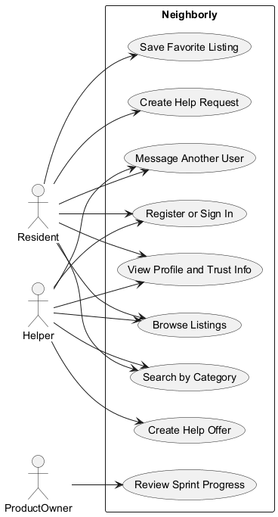

Class Diagram
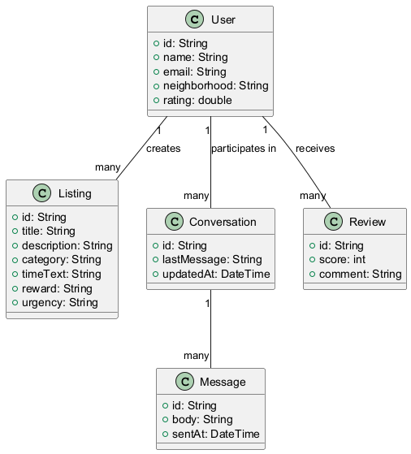

Activity Flow Diagram
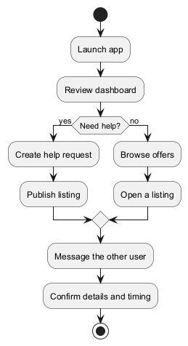

State Diagram for Listings
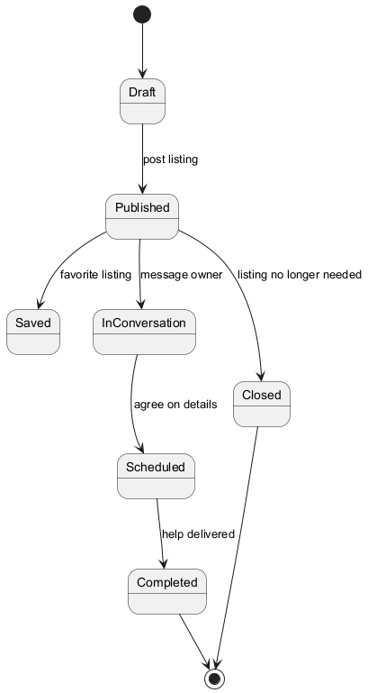

Sequence Diagram: Login
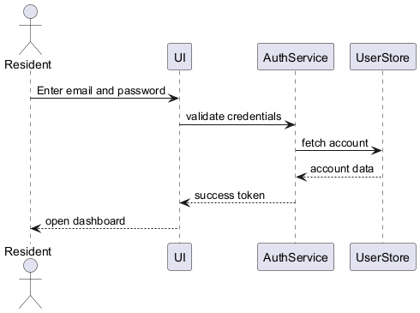

Sequence Diagram: Message Match
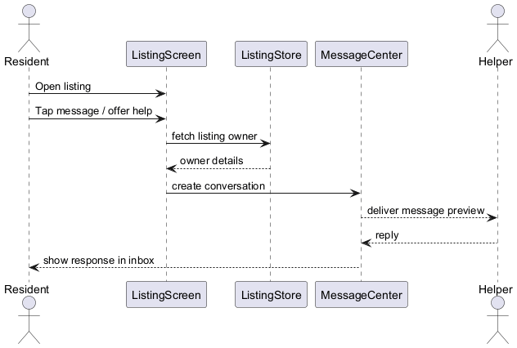

Architectural design
The prototype uses a presentation-first Flutter architecture with a welcome screen, a navigation shell, page widgets for each feature area, and in-memory sample data models for listings and conversations.

Database design
- User
- Listing
- Conversation
- Message
- Review

Interface design
The interface uses a warm community-oriented visual style with green, orange, and blue accents, rounded cards, clear labels, and direct calls to action.

Procedural design
- Open app.
- Review dashboard.
- Search or browse boards.
- Open a listing.
- Message another user or create a new listing.

Screen mockups
Login screen  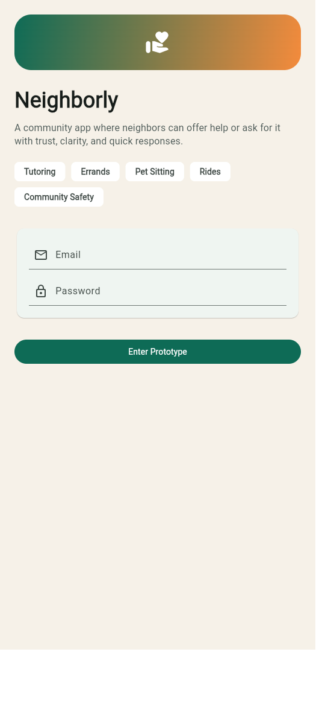 | Home dashboard  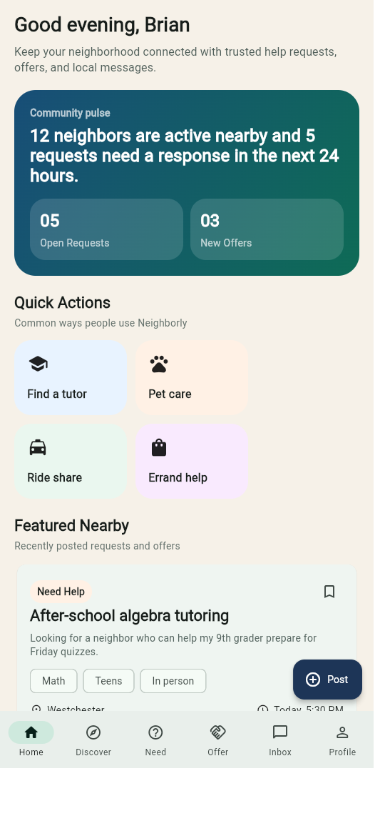

Discover screen  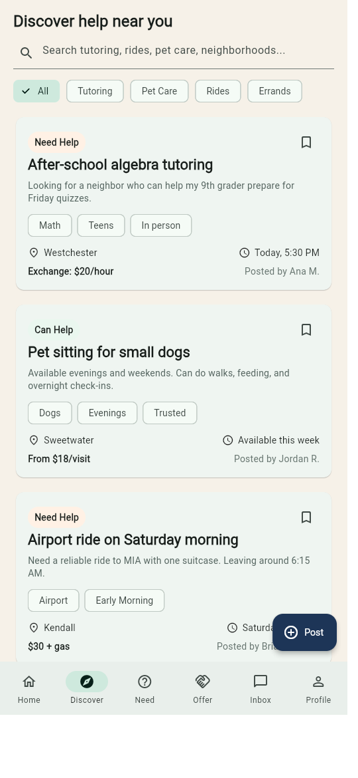 | Need Help board  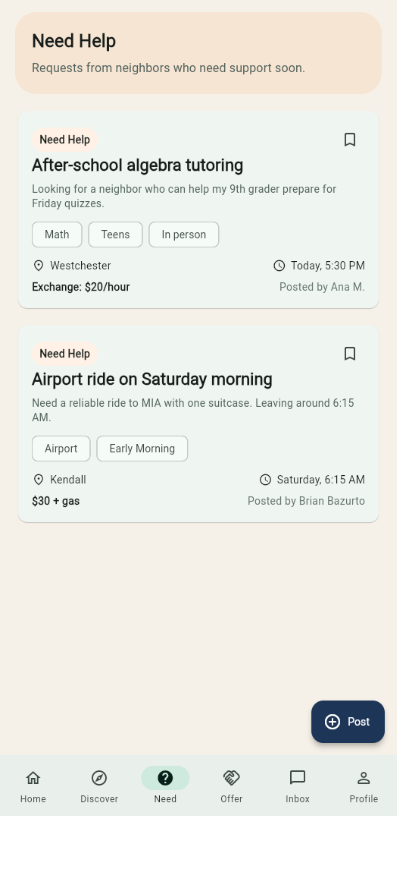

Can Help board  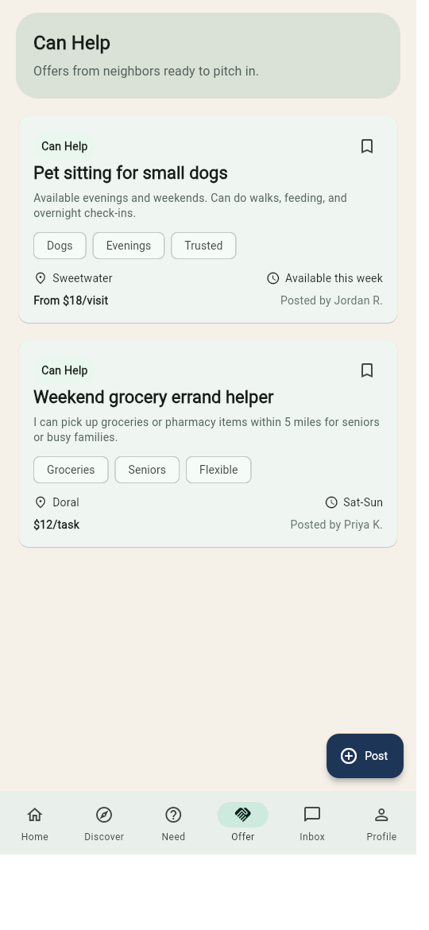 | Inbox  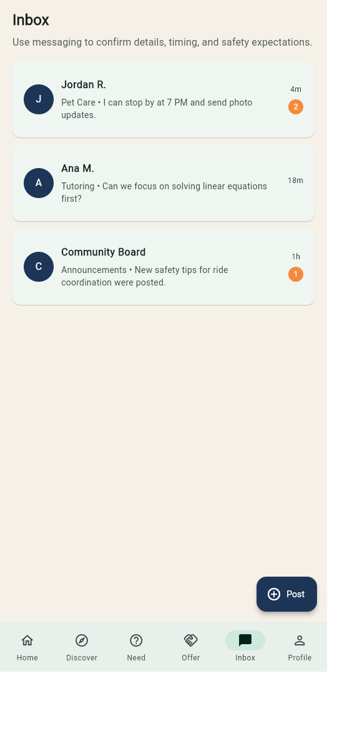

Profile
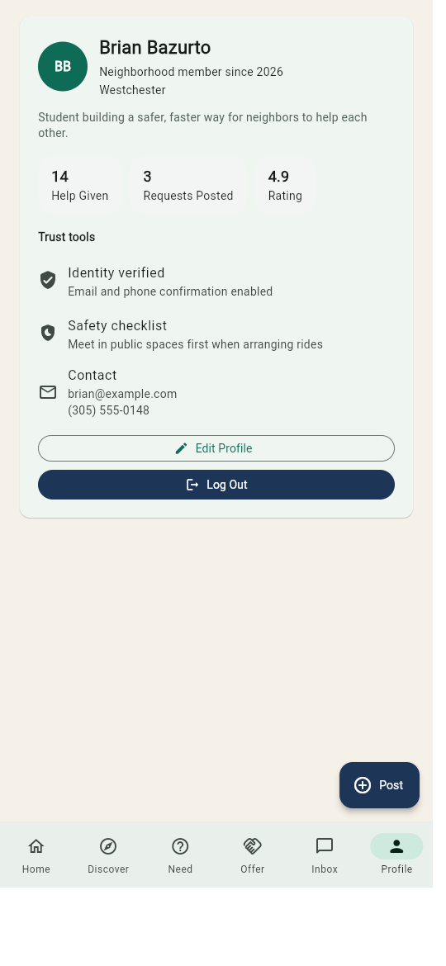

Rationale management

Issues addressed
- How to keep the project realistic for one student while still demonstrating a full software engineering workflow.
- How to show trust and safety in a neighborhood-help product without building a full production backend.
- How to package the Scrum artifacts, UMLs, screenshots, and verification evidence into one final document.

Alternatives considered
- A narrower single-service app such as only tutoring or only rides.
- A production-style backend with authentication and persistent cloud data.
- Separate deliverable documents instead of a single consolidated Word report.

Decisions made
- Use a broader neighborhood-help concept so the project feels current and market-relevant.
- Implement a stable Flutter prototype with local sample data to keep demos reliable.
- Embed the Scrum simulation, UMLs, screenshots, and verification evidence inside one Word submission.

Criteria used to guide decisions
- Semester scope and time constraints.
- Presentation clarity for the professor.
- Traceability from stories to UI behavior and verification evidence.
- Low-risk demos on web and local mobile devices.

Tradeoff discussion
The main tradeoff was depth versus completeness. A live backend would have increased realism, but it also would have reduced the time available for requirements, UML modeling, Scrum artifacts, testing evidence, and presentation quality. The final design favors a strong end-to-end engineering package with a polished prototype over a riskier full-stack implementation.

4. Implementation
The working prototype was implemented in Flutter. The current build includes onboarding, a dashboard, search and category filtering, request and offer boards, inbox previews, a profile screen, and a create-post flow. The design is suitable for web deployment later and for local iOS and Android testing.

Stories per sprint
Sprint | Dates | Goal | Story IDs
Sprint 1 | January 26, 2026 - February 8, 2026 | Establish the trust flow and the first request and offer experiences. | AUTH-01, AUTH-02, AUTH-03, AUTH-04, AUTH-05, LIST-01, LIST-02, LIST-03, LIST-04, LIST-05
Sprint 2 | February 9, 2026 - February 22, 2026 | Complete account support and mature the listing model. | AUTH-06, AUTH-07, AUTH-08, AUTH-09, AUTH-10, LIST-06, LIST-07, LIST-08, LIST-09, LIST-10
Sprint 3 | February 23, 2026 - March 8, 2026 | Deliver discovery, search, and browsing. | DISC-01, DISC-02, DISC-03, DISC-04, DISC-05, DISC-06, DISC-07, DISC-08, DISC-09, DISC-10
Sprint 4 | March 9, 2026 - March 22, 2026 | Deliver inbox and coordination flows. | MSG-01, MSG-02, MSG-03, MSG-04, MSG-05, MSG-06, MSG-07, MSG-08, MSG-09, MSG-10
Sprint 5 | March 23, 2026 - April 1, 2026 | Polish profile, reputation, safety, testing, and presentation readiness. | PROF-01, PROF-02, PROF-03, PROF-04, PROF-05, PROF-06, PROF-07, PROF-08, PROF-09, PROF-10
The story catalog in Section 2 and the consolidated Scrum package in Appendix A make this report the single complete Word submission for the project.

Recorded demo support
Recorded demo assets were also produced for review. The project package includes narrated app walkthrough videos for the overview and create-request flows, which support the sprint review and final presentation requirements.

5. Verification
Verification combined Flutter static analysis, a widget smoke test, and manual walkthrough coverage of the main flows.
Test ID | Description | Expected Result | Mapped Requirements
TC-01 | Create a request | Request appears on Need Help board | LIST-01, LIST-06, LIST-07
TC-02 | Create an offer | Offer appears on Can Help board | LIST-02, LIST-09, LIST-10
TC-03 | Search tutoring | Filtered tutoring results appear | DISC-02, DISC-03
TC-04 | Open detail page | Detail view shows category, timing, owner, reward | LIST-03, LIST-04
TC-05 | Toggle bookmark | Listing save state changes | LIST-05
TC-06 | Open inbox | Conversation previews and unread badges appear | MSG-01, MSG-02, MSG-05
TC-07 | Review profile | Trust and safety tiles appear | PROF-01 to PROF-06
TC-08 | Submit incomplete form | Validation blocks bad input | AUTH-08
TC-09 | Run on smaller screens | No overflow on welcome screen | DISC-10
TC-10 | Run Flutter analyze and test | No analyzer issues and tests pass | Prototype baseline

6. Lessons Learned
The main lesson from this project was that a broad idea becomes manageable once it is broken into features, stories, sprints, and verification targets. A second lesson was that documentation quality improves when the app structure and Scrum artifacts are planned together instead of at the end.

Appendix A. Consolidated Scrum Package
This appendix includes the planning, review, retrospective, and standup content for every sprint so the project can be submitted as one complete Word document.

Sprint 1 Planning
Team Name: Neighborly Solo Team
Date Range: January 26, 2026 - February 8, 2026
Project Lead / Primary Developer: Brian Bazurto
Product Owner: Brian Bazurto
Scrum Master / Developer: Brian Bazurto
Cross-Functional Developer: Brian Bazurto
Tester / QA Reviewer: Brian Bazurto
Sprint Goal: Establish the trust flow and the first request and offer experiences.
Total Estimated Velocity: 30
Story ID | Story Title | Status | Assigned To | Estimate
AUTH-01 | Register account | Planned | Brian Bazurto | 3
AUTH-02 | Sign in | Planned | Brian Bazurto | 3
AUTH-03 | Reset password | Planned | Brian Bazurto | 2
AUTH-04 | View trust badge | Planned | Brian Bazurto | 2
AUTH-05 | Read safety checklist | Planned | Brian Bazurto | 2
LIST-01 | Create help request | Planned | Brian Bazurto | 5
LIST-02 | Create help offer | Planned | Brian Bazurto | 5
LIST-03 | Open request details | Planned | Brian Bazurto | 3
LIST-04 | Open offer details | Planned | Brian Bazurto | 3
LIST-05 | Bookmark listing | Planned | Brian Bazurto | 2

Sprint 1 Review
Sprint Goal Result: Achieved in the course simulation.
Total Velocity: 30
Story ID | Story Title | Status | Assigned To | Estimate
AUTH-01 | Register account | Closed | Brian Bazurto | 3
AUTH-02 | Sign in | Closed | Brian Bazurto | 3
AUTH-03 | Reset password | Closed | Brian Bazurto | 2
AUTH-04 | View trust badge | Closed | Brian Bazurto | 2
AUTH-05 | Read safety checklist | Closed | Brian Bazurto | 2
LIST-01 | Create help request | Closed | Brian Bazurto | 5
LIST-02 | Create help offer | Closed | Brian Bazurto | 5
LIST-03 | Open request details | Closed | Brian Bazurto | 3
LIST-04 | Open offer details | Closed | Brian Bazurto | 3
LIST-05 | Bookmark listing | Closed | Brian Bazurto | 2

Sprint 1 Retrospective

What went well?
- Stories stayed aligned to one theme.
- Prototype and documentation stayed synchronized.
- Scope remained realistic for a solo build.

What didn't go well?
- A live backend had to be deferred for schedule control.
- The amount of formal documentation required careful pacing.

How can we improve?
- Capture polished screenshots earlier in the sprint.
- Review estimates sooner before closing planning.
- Automate more asset generation for the final package.

Sprint 1 Standup Notes

Standup 1 - 2026-01-26
What I did Yesterday: Advanced the current sprint stories and updated the matching documentation.
What I am going to do Today: Continue the next highest-priority story and verify the UI behavior.
Impediments: Balancing prototype work with formal deliverable formatting.

Standup 2 - 2026-01-29
What I did Yesterday: Advanced the current sprint stories and updated the matching documentation.
What I am going to do Today: Continue the next highest-priority story and verify the UI behavior.
Impediments: Balancing prototype work with formal deliverable formatting.

Standup 3 - 2026-02-02
What I did Yesterday: Advanced the current sprint stories and updated the matching documentation.
What I am going to do Today: Continue the next highest-priority story and verify the UI behavior.
Impediments: Balancing prototype work with formal deliverable formatting.

Standup 4 - 2026-02-05
What I did Yesterday: Advanced the current sprint stories and updated the matching documentation.
What I am going to do Today: Continue the next highest-priority story and verify the UI behavior.
Impediments: Balancing prototype work with formal deliverable formatting.

Sprint 2 Planning
Team Name: Neighborly Solo Team
Date Range: February 9, 2026 - February 22, 2026
Project Lead / Primary Developer: Brian Bazurto
Product Owner: Brian Bazurto
Scrum Master / Developer: Brian Bazurto
Cross-Functional Developer: Brian Bazurto
Tester / QA Reviewer: Brian Bazurto
Sprint Goal: Complete account support and mature the listing model.
Total Estimated Velocity: 25
Story ID | Story Title | Status | Assigned To | Estimate
AUTH-06 | Edit profile basics | Planned | Brian Bazurto | 3
AUTH-07 | Keep session active | Planned | Brian Bazurto | 2
AUTH-08 | Validate required fields | Planned | Brian Bazurto | 3
AUTH-09 | Understand welcome screen | Planned | Brian Bazurto | 2
AUTH-10 | Protect trust information | Planned | Brian Bazurto | 3
LIST-06 | Set urgency | Planned | Brian Bazurto | 2
LIST-07 | Show neighborhood | Planned | Brian Bazurto | 2
LIST-08 | Display tags | Planned | Brian Bazurto | 2
LIST-09 | Choose category | Planned | Brian Bazurto | 3
LIST-10 | Show compensation | Planned | Brian Bazurto | 3

Sprint 2 Review
Sprint Goal Result: Achieved in the course simulation.
Total Velocity: 25
Story ID | Story Title | Status | Assigned To | Estimate
AUTH-06 | Edit profile basics | Closed | Brian Bazurto | 3
AUTH-07 | Keep session active | Closed | Brian Bazurto | 2
AUTH-08 | Validate required fields | Closed | Brian Bazurto | 3
AUTH-09 | Understand welcome screen | Closed | Brian Bazurto | 2
AUTH-10 | Protect trust information | Closed | Brian Bazurto | 3
LIST-06 | Set urgency | Closed | Brian Bazurto | 2
LIST-07 | Show neighborhood | Closed | Brian Bazurto | 2
LIST-08 | Display tags | Closed | Brian Bazurto | 2
LIST-09 | Choose category | Closed | Brian Bazurto | 3
LIST-10 | Show compensation | Closed | Brian Bazurto | 3

Sprint 2 Retrospective

What went well?
- Stories stayed aligned to one theme.
- Prototype and documentation stayed synchronized.
- Scope remained realistic for a solo build.

What didn't go well?
- A live backend had to be deferred for schedule control.
- The amount of formal documentation required careful pacing.

How can we improve?
- Capture polished screenshots earlier in the sprint.
- Review estimates sooner before closing planning.
- Automate more asset generation for the final package.

Sprint 2 Standup Notes

Standup 1 - 2026-02-09
What I did Yesterday: Advanced the current sprint stories and updated the matching documentation.
What I am going to do Today: Continue the next highest-priority story and verify the UI behavior.
Impediments: Balancing prototype work with formal deliverable formatting.

Standup 2 - 2026-02-12
What I did Yesterday: Advanced the current sprint stories and updated the matching documentation.
What I am going to do Today: Continue the next highest-priority story and verify the UI behavior.
Impediments: Balancing prototype work with formal deliverable formatting.

Standup 3 - 2026-02-16
What I did Yesterday: Advanced the current sprint stories and updated the matching documentation.
What I am going to do Today: Continue the next highest-priority story and verify the UI behavior.
Impediments: Balancing prototype work with formal deliverable formatting.

Standup 4 - 2026-02-19
What I did Yesterday: Advanced the current sprint stories and updated the matching documentation.
What I am going to do Today: Continue the next highest-priority story and verify the UI behavior.
Impediments: Balancing prototype work with formal deliverable formatting.

Sprint 3 Planning
Team Name: Neighborly Solo Team
Date Range: February 23, 2026 - March 8, 2026
Project Lead / Primary Developer: Brian Bazurto
Product Owner: Brian Bazurto
Scrum Master / Developer: Brian Bazurto
Cross-Functional Developer: Brian Bazurto
Tester / QA Reviewer: Brian Bazurto
Sprint Goal: Deliver discovery, search, and browsing.
Total Estimated Velocity: 27
Story ID | Story Title | Status | Assigned To | Estimate
DISC-01 | Browse dashboard feed | Planned | Brian Bazurto | 3
DISC-02 | Search listings | Planned | Brian Bazurto | 4
DISC-03 | Filter by category | Planned | Brian Bazurto | 3
DISC-04 | Use quick actions | Planned | Brian Bazurto | 2
DISC-05 | See community snapshot | Planned | Brian Bazurto | 2
DISC-06 | Open Need Help board | Planned | Brian Bazurto | 3
DISC-07 | Open Can Help board | Planned | Brian Bazurto | 3
DISC-08 | Recognize listing type | Planned | Brian Bazurto | 2
DISC-09 | Read concise previews | Planned | Brian Bazurto | 2
DISC-10 | Use on web and mobile | Planned | Brian Bazurto | 3

Sprint 3 Review
Sprint Goal Result: Achieved in the course simulation.
Total Velocity: 27
Story ID | Story Title | Status | Assigned To | Estimate
DISC-01 | Browse dashboard feed | Closed | Brian Bazurto | 3
DISC-02 | Search listings | Closed | Brian Bazurto | 4
DISC-03 | Filter by category | Closed | Brian Bazurto | 3
DISC-04 | Use quick actions | Closed | Brian Bazurto | 2
DISC-05 | See community snapshot | Closed | Brian Bazurto | 2
DISC-06 | Open Need Help board | Closed | Brian Bazurto | 3
DISC-07 | Open Can Help board | Closed | Brian Bazurto | 3
DISC-08 | Recognize listing type | Closed | Brian Bazurto | 2
DISC-09 | Read concise previews | Closed | Brian Bazurto | 2
DISC-10 | Use on web and mobile | Closed | Brian Bazurto | 3

Sprint 3 Retrospective

What went well?
- Stories stayed aligned to one theme.
- Prototype and documentation stayed synchronized.
- Scope remained realistic for a solo build.

What didn't go well?
- A live backend had to be deferred for schedule control.
- The amount of formal documentation required careful pacing.

How can we improve?
- Capture polished screenshots earlier in the sprint.
- Review estimates sooner before closing planning.
- Automate more asset generation for the final package.

Sprint 3 Standup Notes

Standup 1 - 2026-02-23
What I did Yesterday: Advanced the current sprint stories and updated the matching documentation.
What I am going to do Today: Continue the next highest-priority story and verify the UI behavior.
Impediments: Balancing prototype work with formal deliverable formatting.

Standup 2 - 2026-02-26
What I did Yesterday: Advanced the current sprint stories and updated the matching documentation.
What I am going to do Today: Continue the next highest-priority story and verify the UI behavior.
Impediments: Balancing prototype work with formal deliverable formatting.

Standup 3 - 2026-03-02
What I did Yesterday: Advanced the current sprint stories and updated the matching documentation.
What I am going to do Today: Continue the next highest-priority story and verify the UI behavior.
Impediments: Balancing prototype work with formal deliverable formatting.

Standup 4 - 2026-03-05
What I did Yesterday: Advanced the current sprint stories and updated the matching documentation.
What I am going to do Today: Continue the next highest-priority story and verify the UI behavior.
Impediments: Balancing prototype work with formal deliverable formatting.

Sprint 4 Planning
Team Name: Neighborly Solo Team
Date Range: March 9, 2026 - March 22, 2026
Project Lead / Primary Developer: Brian Bazurto
Product Owner: Brian Bazurto
Scrum Master / Developer: Brian Bazurto
Cross-Functional Developer: Brian Bazurto
Tester / QA Reviewer: Brian Bazurto
Sprint Goal: Deliver inbox and coordination flows.
Total Estimated Velocity: 24
Story ID | Story Title | Status | Assigned To | Estimate
MSG-01 | Open inbox | Planned | Brian Bazurto | 3
MSG-02 | Notice unread messages | Planned | Brian Bazurto | 2
MSG-03 | Message from request | Planned | Brian Bazurto | 3
MSG-04 | Message from offer | Planned | Brian Bazurto | 3
MSG-05 | See preview context | Planned | Brian Bazurto | 2
MSG-06 | Coordinate timing | Planned | Brian Bazurto | 2
MSG-07 | Coordinate safely | Planned | Brian Bazurto | 2
MSG-08 | Return to active chats | Planned | Brian Bazurto | 2
MSG-09 | Read community announcements | Planned | Brian Bazurto | 2
MSG-10 | Demonstrate end-to-end coordination | Planned | Brian Bazurto | 3

Sprint 4 Review
Sprint Goal Result: Achieved in the course simulation.
Total Velocity: 24
Story ID | Story Title | Status | Assigned To | Estimate
MSG-01 | Open inbox | Closed | Brian Bazurto | 3
MSG-02 | Notice unread messages | Closed | Brian Bazurto | 2
MSG-03 | Message from request | Closed | Brian Bazurto | 3
MSG-04 | Message from offer | Closed | Brian Bazurto | 3
MSG-05 | See preview context | Closed | Brian Bazurto | 2
MSG-06 | Coordinate timing | Closed | Brian Bazurto | 2
MSG-07 | Coordinate safely | Closed | Brian Bazurto | 2
MSG-08 | Return to active chats | Closed | Brian Bazurto | 2
MSG-09 | Read community announcements | Closed | Brian Bazurto | 2
MSG-10 | Demonstrate end-to-end coordination | Closed | Brian Bazurto | 3

Sprint 4 Retrospective

What went well?
- Stories stayed aligned to one theme.
- Prototype and documentation stayed synchronized.
- Scope remained realistic for a solo build.

What didn't go well?
- A live backend had to be deferred for schedule control.
- The amount of formal documentation required careful pacing.

How can we improve?
- Capture polished screenshots earlier in the sprint.
- Review estimates sooner before closing planning.
- Automate more asset generation for the final package.

Sprint 4 Standup Notes

Standup 1 - 2026-03-09
What I did Yesterday: Advanced the current sprint stories and updated the matching documentation.
What I am going to do Today: Continue the next highest-priority story and verify the UI behavior.
Impediments: Balancing prototype work with formal deliverable formatting.

Standup 2 - 2026-03-12
What I did Yesterday: Advanced the current sprint stories and updated the matching documentation.
What I am going to do Today: Continue the next highest-priority story and verify the UI behavior.
Impediments: Balancing prototype work with formal deliverable formatting.

Standup 3 - 2026-03-16
What I did Yesterday: Advanced the current sprint stories and updated the matching documentation.
What I am going to do Today: Continue the next highest-priority story and verify the UI behavior.
Impediments: Balancing prototype work with formal deliverable formatting.

Standup 4 - 2026-03-19
What I did Yesterday: Advanced the current sprint stories and updated the matching documentation.
What I am going to do Today: Continue the next highest-priority story and verify the UI behavior.
Impediments: Balancing prototype work with formal deliverable formatting.

Sprint 5 Planning
Team Name: Neighborly Solo Team
Date Range: March 23, 2026 - April 1, 2026
Project Lead / Primary Developer: Brian Bazurto
Product Owner: Brian Bazurto
Scrum Master / Developer: Brian Bazurto
Cross-Functional Developer: Brian Bazurto
Tester / QA Reviewer: Brian Bazurto
Sprint Goal: Polish profile, reputation, safety, testing, and presentation readiness.
Total Estimated Velocity: 23
Story ID | Story Title | Status | Assigned To | Estimate
PROF-01 | Open profile | Planned | Brian Bazurto | 3
PROF-02 | View contribution metrics | Planned | Brian Bazurto | 2
PROF-03 | See rating summary | Planned | Brian Bazurto | 2
PROF-04 | Review verification tile | Planned | Brian Bazurto | 2
PROF-05 | Review safety tile | Planned | Brian Bazurto | 2
PROF-06 | Use profile as trust surface | Planned | Brian Bazurto | 3
PROF-07 | Prepare for reviews | Planned | Brian Bazurto | 2
PROF-08 | Keep identity consistent | Planned | Brian Bazurto | 2
PROF-09 | Support solo presentation | Planned | Brian Bazurto | 2
PROF-10 | Prepare for deployment | Planned | Brian Bazurto | 3

Sprint 5 Review
Sprint Goal Result: Achieved in the course simulation.
Total Velocity: 23
Story ID | Story Title | Status | Assigned To | Estimate
PROF-01 | Open profile | Closed | Brian Bazurto | 3
PROF-02 | View contribution metrics | Closed | Brian Bazurto | 2
PROF-03 | See rating summary | Closed | Brian Bazurto | 2
PROF-04 | Review verification tile | Closed | Brian Bazurto | 2
PROF-05 | Review safety tile | Closed | Brian Bazurto | 2
PROF-06 | Use profile as trust surface | Closed | Brian Bazurto | 3
PROF-07 | Prepare for reviews | Closed | Brian Bazurto | 2
PROF-08 | Keep identity consistent | Closed | Brian Bazurto | 2
PROF-09 | Support solo presentation | Closed | Brian Bazurto | 2
PROF-10 | Prepare for deployment | Closed | Brian Bazurto | 3

Sprint 5 Retrospective

What went well?
- Stories stayed aligned to one theme.
- Prototype and documentation stayed synchronized.
- Scope remained realistic for a solo build.

What didn't go well?
- A live backend had to be deferred for schedule control.
- The amount of formal documentation required careful pacing.

How can we improve?
- Capture polished screenshots earlier in the sprint.
- Review estimates sooner before closing planning.
- Automate more asset generation for the final package.

Sprint 5 Standup Notes

Standup 1 - 2026-03-23
What I did Yesterday: Advanced the current sprint stories and updated the matching documentation.
What I am going to do Today: Continue the next highest-priority story and verify the UI behavior.
Impediments: Balancing prototype work with formal deliverable formatting.

Standup 2 - 2026-03-26
What I did Yesterday: Advanced the current sprint stories and updated the matching documentation.
What I am going to do Today: Continue the next highest-priority story and verify the UI behavior.
Impediments: Balancing prototype work with formal deliverable formatting.

Standup 3 - 2026-03-30
What I did Yesterday: Advanced the current sprint stories and updated the matching documentation.
What I am going to do Today: Continue the next highest-priority story and verify the UI behavior.
Impediments: Balancing prototype work with formal deliverable formatting.

Standup 4 - 2026-04-01
What I did Yesterday: Advanced the current sprint stories and updated the matching documentation.
What I am going to do Today: Continue the next highest-priority story and verify the UI behavior.
Impediments: Balancing prototype work with formal deliverable formatting.

Appendix B. UML and Screenshot Assets

Appendix B.1 Exported UML Diagrams

Use Case Diagram


Class Diagram


Activity Flow Diagram


State Diagram for Listings


Sequence Diagram: Login


Sequence Diagram: Message Match


Appendix B.2 App Screenshots
Login screen   | Home dashboard  

Discover screen   | Need Help board  

Can Help board   | Inbox  

Profile


